Simple scripts:
Connect to remote server and check the number of shells (cat /etc/shells) create new directory with the name of scripts and move the directory and create a file and entre the scripts in file. Once it got saved and change the permission of the file to able to excute the file and use the command to run the file(./filename)
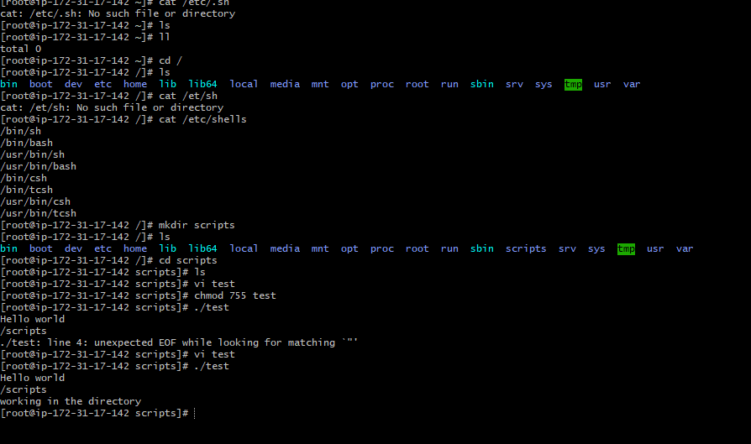
Defining Tasks in the script .
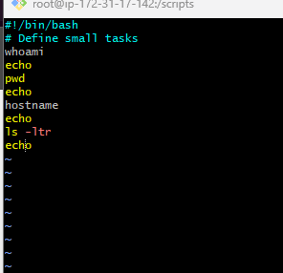
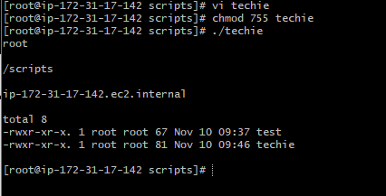
Defining variables:
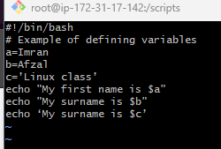
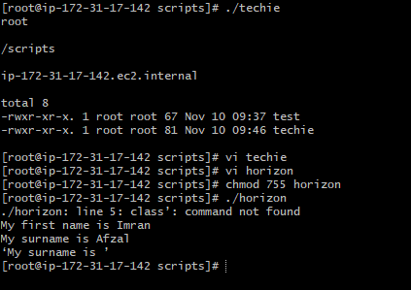
Read Input:
